Minutes
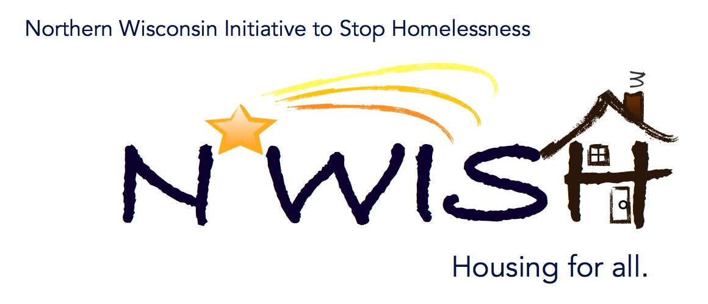
Northern Wisconsin Initiative to Stop Homelessness (N*WISH) Coalition
In-person or Via ZOOM
Zoom Link:
https://us02web.zoom.us/j/86798029037
51 N Brown Street, Rhinelander, WI
August 2, 2023
10:30 a.m. – 12:00 p.m.

Welcome/Introductions
Erika Villacrez – Newcap
Beth Larsen - CW Solutions
Amanda Jahn - the Salvation Army
Leigh Polodna WI BOS
Melissa Walsh, CW Solutions
Shannon Smith AVAIL, Inc
Patsy Johnson-Haney at Newcap
Mindy Lohff, Newcap
Micah Dewing - New Hope Shelter
Julie Odden Northcentral FSET Program CW Solutions
Teleka Dewing, Wasmogeshik Food Pantry, Crandon
Michael Basford - State of Wisconsin
Debra Johnson, CEO Sunshine For Humanity Inc homeless shelter
Kent Kohn, Sunshine For Humanity, Inc homeless shelter
Bobbi Braun, Forward Service Corp
Ashley Durand- W2 Forward Service Corporation
Cassandra Robinson MHS Wisconsin
Jennifer Allen, ICA

June Minutes – VOTE
Beth Larsen made a motion to approve the minutes and Amanda Jahn 2nd

June Monthly PIT –
Housing@newcap.org

Domestic Violence – What to watch for – Then what?
Shannon Smith
Warning Signs: Doors off hinges, unruly, bruises, shaming in front of you, isolation, not allowed to speak with you, unable to provide emergency contact,
What to do – connect with local agencies – give brochures, info cards, palm card, nail file, something inconspicuous with phone number on, FB info with a number to call with help. Help them get help to reach out to DV
Or Police, isolation sometimes aren’t allowed phones. Avail has things they can give out that has their number on them. Who should get these.
When do they start planning to leave, how many times have they tried to leave. Websites w/quick exits on so it doesn’t show what website they were on.

YAB Update
Consistent need for youth that want to attend the meetings. Need Youth
Shannon, Avail works with a school social worker will bring it up to them. One YAB member participated in the July PIT Count. We currently only have one YAB member in NWISH. We want our Youths voice heard in our communities.

YHDP “MOST” Project Update
Waiting for the second proposal then the YAB will vote on the best option for the wrap of the MOST Outreach Vehicle.

COC Application
Email sent out 8/2/2023 With
Due 8/29/2023
Bonus projects – New available, more DV RRH funding as well available
Reach out to Leigh if you have any questions.

Action Plan 2.0
DEI Survey is being completed and will be sent out for all our agencies to have their clients fill out so we can get the necessary data we need.

PIT July
Melissa observed 2 people, Erika hasn’t received any sheets from people. Micha went out and counted, he knows of 4 individuals that are homeless, but didn’t see anyone on the date, he also followed up with local police departments asked for them to text him so he could go and follow up with them, no contacts were made.
Before the count we sent out a lot of info out the local area as to resources about the count, we received no information.

Coordinated Entry Lead Update

Housing Updates
Are pulling for all of our programs, if you have people that need housing or have a place that we could do intakes with locals that are in need housing. Please forward and new landlords and apartments and housing that is available in any of our counties to Nicole at nicolemarchand@newccap.org so we can reach out and hopefully find more available housing.
Shannon Avail – has some one on the list that has been in shelter for some time – Erica has explained how prioritization list, how it works. Shannon asked how they can get housing faster, what are the procedures that need to be done to get status of the list. Can call the client so we can give them help.
Ashley Durand asked – What to do to if we find someone that needs housing or is homeless?
Call 800-242-7334 (Newcap’s 800 number) M-F Crisis Mitigation Coach will answer phones will provide update and find someone to follow up with them. If it is after regular business hours, phones are routed to Interim Housing locations, and they can look into system and provide updates to them about their place on the list or they can update their information.

Balance of State Updates
Leigh –
HIC guide and training went out to PIT Leads. If you work with the HIC it has everything you will need to know and why it is so important to make sure it is accurate. WIBOS is also creating a PIT guide for leads and new training for PIT leads. Trainings will be on the WIBOS website as well. It will include what are the pieces of the PIT and how does it fit and PIT methodology process (helpful blueprint), Leigh is writing it down with Carrie. Hopefully this document will help to guide coalitions on how to structure the PIT and what are the expectations of volunteers. Please note observation forms will not be used any longer.
BOS Board applied for Otto Bremer Foundation Grant – potential cool things coming from grant if approved – ability to pay for local YAB going forward into 2024 and some training experiences for board, etc. The WISBOS is looking for more funding opportunities that do not have HUD restrictions.
BOS virtual meeting is August 11 from 9a – 2pm.
The February in-person meeting with business meeting that will include trainings, etc. It will be a great event hope to see everyone there.
Leigh is done the end of Sept. Kate M will be taking over Leigh’s role with NWISH.
The other information for COC Applications is due August 21.
Will save the document in a Google Doc so anyone can fill in their information and then will schedule another meeting to go over the information.
Lots of information that is needed from members that will need to collaborate in a meeting. To be scheduled ASAP.

Agency Updates, Future Presentations & Agenda Items
In-person meetings, hybrid, discuss, Micha is ok with Virtual but in person would be nice. Hybrid for virtual and in person. Shannon Smith agreed. No other input. Erika with Newcap will follow up with staff to see when we can possible start with a in-person meeting with a on-line option.

Motion to Adjourn – Shannon, Micha 2nd

Next N*WISH meeting
In-person possibly or Via ZOOM
September 6, 2023 - 10:30 am – 12:00 pm

“We strive to host inclusive, accessible events that enable all individuals, including individuals with disabilities, to engage fully. To request an accommodation or for inquiries about accessibility, please contact Debbie Bushman, debbiebushman@newcap.org, 800-242-7334”

Please sign up for the Wisconsin Balance of State Newsletter www.wiboscoc.org, Home Page, click “Who are we?” to register

