8/11/2023
The Wisconsin Association for Homeless and Runaway Services is opening their annual training conference to outside agencies and professionals who are interested in learning about and contributing to best practices and current resources for youth experiencing homelessness in Wisconsin and the agencies and professionals who serve them. This two-day event (September 26 and 27, Stone Harbor Resort, Sturgeon Bay) will include direct practice training, open discussion, exploration of current trends and resources, and opportunities to engage with policy advocates at state and national levels. We will be diving into policy and advocacy work that has been directly developed based on youth input under the YHDP CCP and the projects implemented under the YHDP. WAHRS is also working to expand the level of youth involvement in this conference. WAHRS has the space and some resource capacity to support youth involvement and leadership in the conference. Individuals who are interested in learning more and becoming involved can:
- Register for the conference directly (see brochure)
- Support young people and staff in attending (see brochure – reach out to Joli to answer any questions around youth participation)
- Support young people who might be interested in leading or coordinating YAB or YAG involvement at the event (reach out to Joli for introductions)
- Support staff or young people who would like to participate in weekly conference workgroup meetings happening on Mondays at 12pm (Joli can provide a link if emailed directly)
- Support involvement of a few key legislators. If you have ideas, please reach out or get involved in the Monday workgroup
- WAHRS funding to support youth involvement is very limited so we are looking for agency and outside resource support for youth participation. We do have agencies traveling from throughout the state and are likely to help coordinate around transportation.
Questions can be directed to joli@wahrs.org
Register at https://docs.google.com/forms/d/e/1FAIpQLSdqT_Y4IJxeZxmbVNpg3IP3mLLoK16fwQQ6vpF4m4xj_MVocA/viewform?usp=sf_link
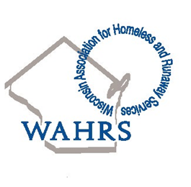
Joli Guenther
Executive Director
Wisconsin Association for Homeless and Runaway Services
www.wahrs.org
joli@wahrs.org

